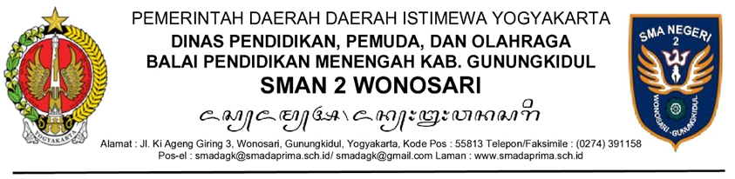

NOTULA

Sidang/rapat : ....................................................................................................
Hari/Tanggal : ....................................................................................................
Surat Undangan : ....................................................................................................
Waktu Sidang/Rapat : ....................................................................................................
Acara : 1. ................................................................................................
2. dan seterusnya.
Pimpinan Sidang/Rapat
Ketua : ....................................................................................................
Sekretaris : ....................................................................................................
Pencatat : ....................................................................................................
Peserta sidang/rapat : 1.................................................................................................
2.dan seterusnya.
Kegiatan Sidang/Rapat: (disesuaikan dengan kondisi kegiatan sidang/rapat) .....................

Pimpinan Sidang/Rapat
Nama Jabatan…….,

Nama Lengkap dan Gelar

